IFG Adventure 3rd Year Motherz Day Interest
Term Two – Week One


Aim: To teach the girls that their mothers (or grandmothers, or other mother figure in their lives) are very special people. God wants us to be thankful for our mothers and honour them.

Objectives: The girls will make a gift for their mum for Mother’s Day.

Preparation:
- Choose from the ideas below, or use your own ideas.
- Gather together all requirements for the activity chosen.

Devotions:
As the old proverb goes, "God couldn't be everywhere, therefore he invented mothers."
Have you ever wondered how Mother's Day got started? People started honouring mothers a very long time ago. When it first started it was called Mothering Sunday because people celebrated it on the fourth Sunday during a time called Lent. Lent is the time before Easter where people think and prepare about the Easter story and what God did for us.
Then 150 years ago a woman named Anna Jarvis, organized a day to raise awareness of poor health conditions in her community, something she thought mothers believed in doing. She called it "Mother's Work Day."
After Anna Jarvis died, her daughter (also named Anna) wanted to honour all that her mother had done. Anna heard her mother say that one day she hoped someone would make a special day just for mothers.
So Anna worked very hard and even talked to presidents and other leaders to try to create a special day just to honour them. By 1914 (almost 100 years ago) a man named Woodrow Wilson signed a bill recognizing Mother's Day as a national holiday.
It just so happened that Anna's mother’s favourite flower was the white carnation and that's why mothers often receive carnations on Mother's Day.
The funny thing is, Anna ended up disliking Mother's day. She didn't want Mother's day to be all about expensive gifts and fancy flowers, but just a day to tell your mom that you love and appreciate her. So remember, mums don't need all that fancy stuff. Make her a nice card and treat her very special today (and everyday) and she won't need anything else.
Mothers are very special, so special that they are mentioned in the Bible. Since the Bible is like an instruction manual for us, it gives us instructions on how to treat our mother. Do any of you know what the Ten Commandments are? They were rules that God gave to Moses for all of us to follow. Each commandment is very important and God gave each commandment for a reason. One of the commandments says: Honour your father and you mother, so that all may go well for you and that you may enjoy long life on the earth.
What does honour mean anyway? Honour can mean many things. When we listen, obey, love, appreciate, and forgive our mum that is how we honour her. That means when she asks you to do something you should do it right away without complaining.
When you show you love your mum by hugging her and telling her that you love her that's another way to honour. You can also appreciate your mum by thanking her when she does things for you (cleaning the house and your clothes, cooking your meals, helping you, etc.).
Our mum won't be perfect all the time, we all make mistakes. So we should forgive our mums when they make mistakes because God asks us too.
Another verse in the Bible asks us to bless our mum. It says, ”Her children arise and call her blessed." Some words that describe blessed are that your mum belongs to God and we need to treat her like she's God's child. Your mum used to be a child too and she's just trying her best to help you grow and learn things. So, treat her nicely!
Another way to describe blessed is to be happy. Do you make your mum happy? I'm sure you do a lot of the time and mums can be sad because of different things sometimes too, but I don't think your mum would be happy if you didn't listen to her or disobeyed her.
The last verse we're going to talk about today says: Children, obey your parents in everything, for this pleases the Lord. I know that sometimes you don't always want to obey your parents but it’s important that you obey them because it makes God happy!
One last thing. No matter how old you get your mum is your mum. Sometimes you might think that you can talk back to your parents or that you know more than them, but you don't. The Bible says to obey your parents always, not just when you’re a girl. Your parents want the best for you and know what they're talking about.
Don't forget that we also have a heavenly father that cares and loves us no matter what. So if you don't have a mother around all the time (or even if you do) God is always there. He is there when our mother can't be.

Teaching Session ideas:
There are a few options here for you to choose from:

Cupcake Card:

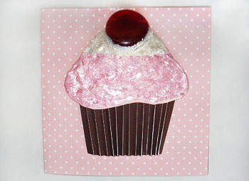
What you'll need:
- White cardstock
- Design cardstock
- Dark brown cardstock (5cmW x 10cm L)
- 3-D pink and white iridescent fabric paint
- Double-sided padded tape
- Glass gem (large)
- Glitter white
- Glue gun
- Cutting knife (for scoring)
- Pattern on http://crafts.kaboose.com/sweet-cupcake-mothers-day-card.html

How to make it:
- Cut out a 14cmW x 28cmL rectangle on design cardstock.
- Fold in half.
- Trace and cut cupcake pattern on white cardstock.
- Score a 4mmW sized pleat with a cutting knife, fold and repeat while alternating sides using dark brown cardstock (for cupcake wrapper).
Making the cupcake:
- Wrap pleated dark brown cardstock around bottom of cardstock cupcake.
- Glue side edges on back of cupcake.
- Place double-sided padded tape on back of cupcake.
- Place cupcake on front center of card.
- Cover (A) with pink 3-D fabric paint for icing. Let dry.
- Cover (B) with white 3-D fabric paint for icing. Let dry.
- Place double-sided padded tape on the back of pink and white icing.
- Place pink icing on top of cupcake, securing with the double-sided tape.
- Place white icing on top of pink icing, securing with the double-sided tape.
- Cover cupcake with a second layer of pink and white icing
- Cover white icing with white glitter
- Glue a large glass gem on top center of cupcake. Let dry.

Tips:
- Replace pleaded dark brown cardstock with half of a real cupcake paper cup.

Mothers Day braided necklace

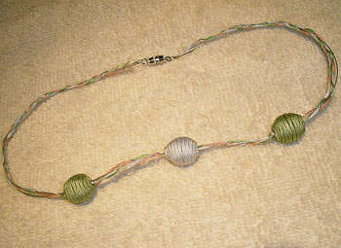
What you'll need:
- Three 56cm lengths of six-strand embroidery floss in coordinating colors (in the picture they have used dusty pink, pale blue, and mossy green).
- 3 large beads, one in one color (a), two in the other (b).
- Blunt point needle or pin for pushing braid through beads
- Two sets of closure clasps
- Two crimping beads
- Coordinating bead stringing wire (used here is a silver tone to go with the silver clasps and crimping beads)
- Needle-nose pliers
- Scissors
- Two spring clip to block the ends of the wire while stringing
- A bead board, or clean white towel for laying out beads
- Hot glue gun

How to make it:
- Lay all three embroidery floss strands and the jewelry string together, gather at one end, and tie into a knot. Grouping the jewelry string with one of the colors, braid the three pieces together. (See photo.) Secure the end with a very tiny dot of hot glue.
- Figure out the three spots you want the beads to appear on the braid. String one of the colour "b" beads onto the braid and push it to a place you want the first bead to appear. (Use the blunt point needle if necessary.) Then tie a knot to the right side of the bead.
- String the colour "a" bead, and then tie the second knot on the left side of the second bead. Tie a third knot in the place you'd like the last bead to hang, then string the second color "b" bead onto the braid, allowing it to fall to the right of the last knot.
- Using the hot glue gun, glue each end to secure the floss along with the jewelry string, to keep it from sliding down while worn.
- Adding the closures: String a crimping bead onto one end of jewelry string, string one half of the closure, then bend the wire, coming back down the opposite way, through the crimping bead, letting an adult crimp it tightly with the needle-nose pliers. Secure the other half of the closure on the other side, using the same method. This should create a nice, snug clasp.

Tips:
- Using a sewing pin or bobby pin could also help you push the braid through the bead.

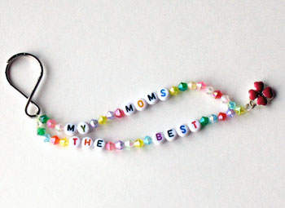
My Mum’s the Best Keychain:
This pretty keychain will tell mum just how much you love her! With pretty coloured beads and a personal message, your mum will cherish this gift.

What you'll need:
- Alphabet beads to spell "MY MUMS THE BEST"
- Colourful beads to fill in gaps (approximately 30-40)
- Colourful charm
- Keychain ring
- 60cm stretchy jewelry cord, cut into two equal pieces

How to make it:
- Line up the two pieces of jewelry cord side by side, then gather one end together and tie in a triple knot to the keychain ring.
- Thread 4-5 colourful beads onto one side of the jewelry cord.
- Thread on the letters T H and E, be sure they are facing the correct direction.
- Follow with 4-5 more colourful beads.
- Add the letters B, E, S and T.
- Add 4-5 more beads.
- Carefully set the finished cord aside, taping the end of the cord to the table will keep the beads from falling off.
- On the other string, add 3-4 colourful beads, then the letters M and Y.
- Next add 3-4 more colourful beads, and then the letters M, U, M and S. (See photo.)
- Add 5-6 more colourful beads.
- Lay the two strings alongside each other and add beads to the shortest side to get them even.
- Holding the two ends of the jewelry cord as close to the last beads as possible, thread one last colourful bead onto BOTH strings. Run the string through the bead again by looping it through the top and pulling it tight. (See photo.)
- Tie the charm to the end of the string, knot it several times and trim ends. Don't trim it too close!

Tips:
- For younger children you can use pony beads and larger alphabet beads as well as hemp or thicker jewelry cord.
- If you like, instead of the phrase, make up your own phrase or use mum's first name.
- This keychain also makes a lovely addition to mum's work desk hanging on a pushpin!

Closing Prayer
Notices
Home

